**An Evaluation Model of COVID-19** **Prevention and Control Effectiveness Based on Immigration Population Data in China**

Qiangsheng Huang

**Abstract**

**Background:** As of the end of February 2020, COVID-19 was currently well controlled in China. However, the virus is now spreading globally.

**Objective:** This study aims to find a method to evaluate the effectiveness of COVID-19 prevention and control in different regions of China. And warnings can be issued at the first time when the prevention and control have problems.

**Methods:** A model is built based on two sets of data (the number of daily new diagnosed, and the daily incoming immigration population size). The outputs from the model can be used to evaluate the effectiveness of outbreak prevention and control in each regions of China.

**Results:** The model can evaluate the effectiveness in each region on each day accurately, with the confirmation of related reports and news.

**Conclusions:** This method is the first one to evaluate the effectiveness of COVID-19 epidemic prevention and control in China base on immigration population data. It has the advantage of early warning over the method by R0. Theoretically, it is applicable to evaluating the effectiveness of COVID-19 prevention and control in other countries.

Key words: COVID-19; 2019-nCoV; Epidemic Prevention and Control; Big Data Analysis; Data mining; Mathematical modeling

**Introduction**

**Limitations of Traditional Method for COVID-19 Prevention and Effectiveness Evaluation**

It has been 3 months since the first case diagnosed as COVID-19 in Wuhan, Hubei, since December 2019. Chinese were ignorant of it from the beginning. For example, the people of Wuhan held a banquet for tens of thousands of people in January 18th, which caused the spread of the epidemic [1]. Then, Chinese gradually paid attention to the investigation and control of incoming immigration population, closed down some densely populated regions, and went out with masks, and so on [2, 3].

These traditional methods for COVID-19 prevention and control are important and necessary. However, other measures need to be taken as supplements. For example, people with no symptoms can also infect others during their incubation period [4]. Therefore, the method of measuring the temperature of people entering public places can only find a part of infected people.

And we can obtain some estimates of the effectiveness of epidemic prevention and control from statistical data such as the number of daily new diagnosed patients in every regions of China [5, 6, 7].

These methods can be used to analyze the situation in some aspects. However, they cannot used to evaluate the prevention and control effectiveness in the regions of China. Because they haven’t been combined with the information of immigration population during the outbreak. Suppose there’s a scenario that Province A and Province B have the same daily new diagnosed numbers during the outbreak period. However, the diagnosed in Province A are almost incoming infected people, and most of them are diagnosed at their incoming day. On the contrary, the diagnosed in Province B were almost inner people, and most of the incoming infected people were diagnosed a week after their coming in. All the infected people in Province A and B are isolated until being diagnosed. We should consider that the epidemic prevention and control effectiveness in Province A was better than that in Province B, because the virus spread more severely in province B.

**Importance of Migration Population Data Analysis for COVID-19 and A Successful Case**

Chinese President Xi and Chinese Government emphasized the importance of the analysis of big data, especially migration population data, in COVID-19 prevention and control in Mid-February [8, 9]. Currently we can see a successful case of immigration population data analysis. “Health Code” was created [10] and was applied to various regions [11, 12, 13, 14]. It is a mobile app used to detect if someone, who will go into the public places, has been to the place where an epidemic happened recently by the positioning function of his mobile phone. The method of measuring body temperature combined with “Health Code” can prevent risk or potentially infected people from entering public places much more effectively.

**Evaluation Method for COVID-19 Prevention and Control Based on Immigration Population Data**

By using migration population data from Baidu, there were some analysis reports on the trend of population movement during the COVID-19 [15, 16]. However, at present, there is no method of evaluation for the COVID-19 prevention and control effectiveness based on migration population data in China. This study owns a similar but not identical idea to “Health Code” that using immigration population data to evaluate the risk of immigration population into a region. And a model is built to evaluate COVID-19 prevention and control effectiveness in the region of China. By using this method, regions with poor epidemic prevention and control can be detected as soon as possible.

The result of this study had been acknowledged by the Ping An Institute of Macroeconomics, which has provided macro research reports to the Chinese government for many years. And it had been submitted to the Chinese Government for reference by the institute in February 2020.

**Methods**

**Abbreviations**

To simplify the description, the abbreviations are used for the following nouns in the later paper:

The provinces / municipalities of China is referred to as “region”.

The daily new diagnosed in each region is referred to as “daily new diagnosed” or just “new” (in quotes).

The sum of “new” values in the recent 3 days is referred to as “accumulated new” (in quotes).

The daily incoming immigration population size in each region is referred to as “daily incoming population” or just “population” (in quotes).

The risk of daily incoming immigration population in each region is referred to as “daily immigration risk” or just “risk” (in quotes).

The offset parameter in the model is referred to as “offset” (in quotes).

The window parameter in the model is referred to as “window” (in quotes).

The sum of “offset” and “window” values for a region in one day is referred to as “offset + window” (in quotes).

The “risk” data processed by “offset” and “window” parameters is referred to as “processed risk” (in quotes).

The correlation coefficient of “new” and “risk” (or “processed risk”) is referred to as “corr” (in quotes).

**Overview**

A model is built to evaluate the effectiveness of prevention and control for COVID-19 in all regions of China. The main theory, which will be introduced later in detail, is that both the “offset” and “window” parameters in the model are used to reveal the delayed days of “risk” convert to “new”. More days means worse effectiveness. The model workflow is shown in Figure 1. These are three main steps in this model for evaluate a single region in a period of days:

First, “risk” data is constructed from “population” and “new” data.

Second, “risk” data is processed into “processed risk” data by “offset” and “window” parameters.

Last, the “offset” and “window” values corresponding to the largest correlation coefficient of “new” and “processed risk” data are the output of the model.

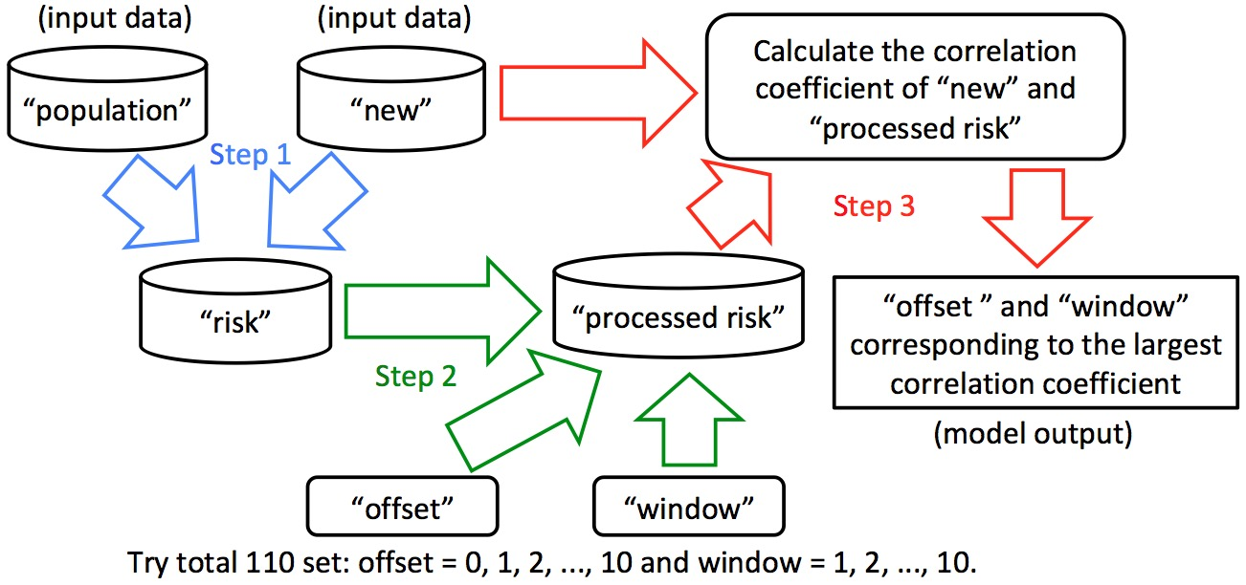

Figure 1. The Model Workflow

**Model Input Data**

***Model Input Data 1: Daily New Diagnosed Data in Each Region (the “new” Data)***

Since January 17th, 2020, various provinces / municipalities in China have successively announced data such as the number of new daily diagnoses. The “new” data is crawled from Doctor Lilac Network (<https://ncov.dxy.cn/>).

***Model Input Data 2: Daily Incoming Immigration Population Size Data in Each Region (the “population” Data)***

The immigration population and its control must be the most important factor affecting the developing trend of the epidemic situation. Therefore, the daily incoming immigration population data, which are distinguished from different source regions, is crawled from Baidu Migration (<https://qianxi.baidu.com/>).

Because no immigration population data was got for Hong Kong, Macao, and Taiwan, and the traffic of Hubei has been closed from late January, these regions hadn’t been analyzed. However, the immigration population moved from Hubei to other regions where were analyzed were considered.

**Daily Immigration Risk Data in Each Region (the “Risk” Data)**

It should be considered that the incoming immigration populations with same size from different sources have different degree of risk. For example, early in the spread of the virus, people from Hubei, where the situation was much more serious, had greater risk than that from other regions with the same immigration population size. Therefore, “population” is processed as Formula 1, and the “risk” data is constructed.



Formula 1. Calculation of “Risk”

In the Formula 1, all the values of “risk”, “population” and “accumulated_new” are in a same day.

“riski” is the “daily immigration risk” of region i in one day. (i can be 1, 2, 3, …, n. “n” is a fix number. And in this study “n” is 31, because this study analyzed 31 regions including Hubei. And i in this study cannot be the number of Hubei for the reason mentioned.)

“populationj” is the “daily incoming population” from source region j. (j can be 1, 2, 3, …, n, and j cannot be same as i.)

“accumulated_newj” is the sum of “new” in immigration source region j in recent 3 days, and its calculation is as Formula 2. “accumulated_newd” is the “accumulated_new” on the date of “d”.



Formula 2. Calculation of “Accumulated New”

**Introduction for “offset” and “window” parameter**

***The “offset” parameter, which is used to evaluate the control for incoming immigration population***

On the one hand, for the incoming immigration population, the prevention and control are different at different times or in different regions. For example, in some regions, the temperature of immigrants, cough and other medical examinations are strictly investigated relatively early. Such strict external people flow controls cause many infected immigrants are diagnosed and isolated immediately. So “new” increases significantly on the day when “risk” is suddenly high. On the contrary, these externally infected people will be finally diagnosed relatively later. Therefore, the concept and the parameter of “offset” are introduced. The “offset” is the number of days “risk” shifted. For example when “offset” is 3, it means that the “risk” of each day is processed as the “risk” of 3 days ago.

***The “window” parameter, which is used to evaluate the control for inner people***

On the other hand, the control of internal people and their own awareness of prevention can also affect the spread of the epidemic. In some regions, the immigrants are strictly isolated at home for 14 days [17]. Such rigorous measures keep potentially infected people entered the region from transmitting the virus to others. In this model, under ideal circumstances, if only externally infected people are infected themselves, there will be only “offset” alone. On the contrary, suppose the scenario that the infected person who has moved into the region (have been sick or incubated) does not seek medical treatment immediately, or poor awareness of inner people such as going out without a mask make the virus spread to more people. So the impact of “risk” can last more days. Therefore, the concept of window is introduced into the model. For example, when “window” is 10, it means that the total “risk” of 10 consecutive days will affect the “new” on the 10th day. From reference [18], we can know the incubation period with 95% confidence interval is 4.1-7.0 days, so if the infected person who moved in 10 days ago can still affect the inside, it should be spread much serious from person to person.

**Process “Risk” Data by “Offset” and “Window”**

Based on the analysis and the concepts introduced above. The “risk” can be processed by “offset” and “window” as Formula 3.

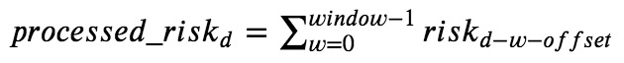

Formula 3. Calculation of “Processed Risk”

In Formula 3, all the “processed_risk” and “risk” is for a same region.

“processed_riskd” is the value of processed “risk” by “window” and “offset” on the date of “d”.

“riskd-w-offset” is the value of “risk” at the date of “d-w-offset”.

For example, if it is needed to calculate the value of “processed_risk” in 2020-02-11, when “offset” is 3, “window” is 2. The formula is as follow:



Formula 4. Calculation of “Processed Risk” (d=2020-02-11, offset=3, window=2)

And when “offset” is 0, “window” is 1. “processed_riskd” is just “riskd” without any process:



Formula 5. Calculation of “Processed Risk” (offset=0, window=1)

**Calculation of Correlation Coefficient between “New” and “Processed Risk”, and Model Outputs**

The final step of this model is to find a set of “offset” and “window” as the best fit for “new” and “processed risk” of each region in each day.

For each region in each day, starting from January 17th, 2020 (the first day of accurate “new” data collected), the “offset” is tried from 0 to 10, and the “window” is tried from 1 to 10. There are 110 different “offsets” and “windows” sets. The 110 sets are used to process “risk” one by one, and calculate the 110 correlation coefficients with “new” and “processed risk”. Finally, the set of “offset” and “window” corresponding to the maximum correlation coefficient is just the model output for the region in the day.

**Results**

**Processing “Population” and “New” into “Risk”**

As Formula 2, “accumulated new” is processed from “new”. For example, the process of Hubei in first 6 days is shown as Table 1. (No accurate data is found before January 17, so the values before that day are set to 0.) Similar calculations are performed in other 30 regions in each day.

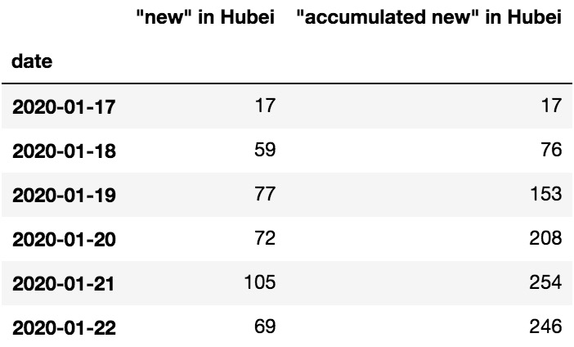

Table 1. The “accumulated new” processed from “new” in Hubei

Then as Formula 1, “risk” is processed from “population” and “accumulated new”. For example, the total “population” into Jiangsu and Heilongjiang and the total “accumulated new” of source regions in each day is compared with their “risk” in Figure 2 and 3. (On the one hand, in Formula 1, there should be 30 incoming “population” and “accumulated new” for every source regions, but too many polylines to be plotted in the chart. So the total “population” and “accumulated new” polylines are plotted. On the other hand, because the values of “risk” are very large values, drawing them with “population” and “accumulated new” will make “population” and “accumulated new” polylines as a very low horizontal line. Therefore, the maximum “population” and “accumulated new” values are set to the maximum “risk” value, and the remaining values are increased in proportion.)

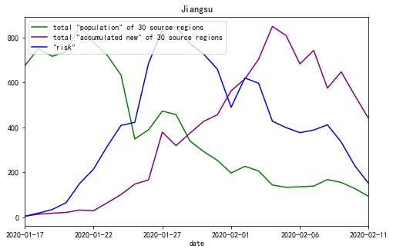

Figure 2. “Risk” of Jiangsu Calculated by “Population” and “Accumulated New” from 2020-01-17 to 2020-02-11

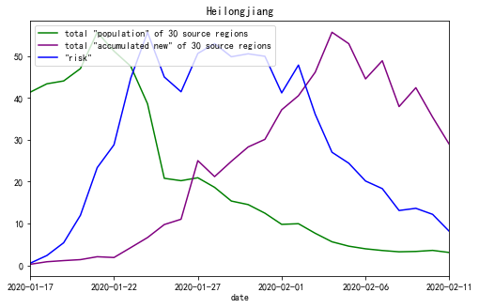

Figure 3. “Risk” of Heilongjiang Calculated by “Population” and “Accumulated New” from 2020-01-17 to 2020-02-11

Table 2 shows the maximum, average, minimum “risk” values and the dates of maximum and minimum “risk” in the 9 regions mentioned in this paper in these days, as a summary.

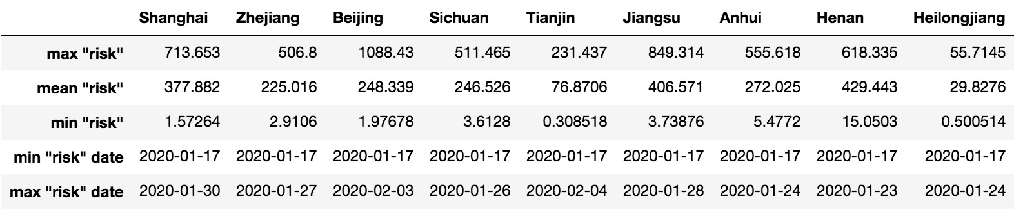

Table 2. The summary of “risk” in 9 regions from 2020-01-17 to 2020-02-11

**Processing “Risk” into “Processed Risk” and Calculation of Correlation Coefficient**

In each region on each day, there are 110 sets of “offset” and “window” used to process “risk”. Due to the huge amount of data, “new”, “risk” and the “processed risk” processed by the model outputs in Jiangsu and Heilongjiang on February 11 are used to illustrate the role of “offset” and “window” parameters by line charts.

The polyline charts of “new” and “risk” are shown in Figure 4 and 5. (Because the values of “risk” are very large values, drawing them with “new” will make “new” polyline as a very low horizontal line. Therefore, the maximum “risk” values is set to the maximum “new” value, and the remaining “risk” values are reduced in proportion.) The correlation coefficient values of “new” and “risk” of Jiangsu and Heilongjiang are 0.684 and -0.014. The value of Jiangsu is not high enough, and the one of Heilongjiang is almost completely uncorrelated.

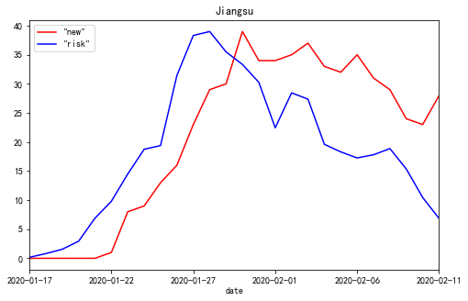

Figure 4. The polyline chart of “new” and “risk” for Jiangsu Province from 2020-01-17 to 2020-02-11

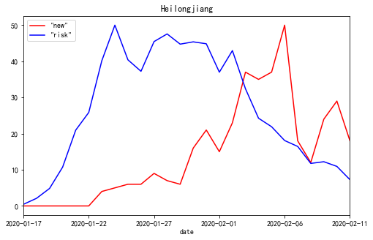

Figure 5. The polyline chart of “new” and “risk” for Heilongjiang Province from 2020-01-17 to 2020-02-11

If “processed risk” is instead of “risk” to draw the polyline chart, the polylines are much more fitted as illustrated in Figure 6 and 7. And the correlation coefficient values increase to 0.979 and 0.874.

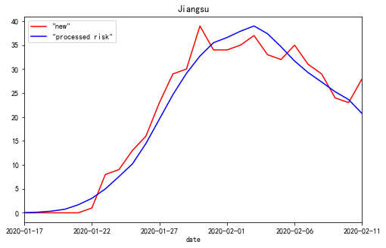

Figure 6. The polyline chart of “new” and “processed risk” for Jiangsu Province from 2020-01-17 to 2020-02-11, when offset=0, window=9

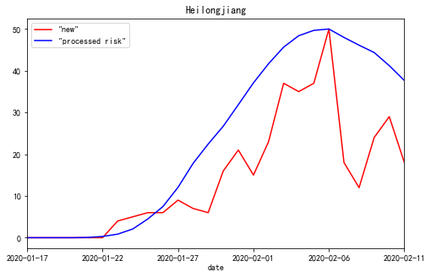

Figure 7. The polyline chart of “new” and “processed risk” for Heilongjiang Province from 2020-01-17 to 2020-02-11, when offset=4, window=10

From Figures 4, 5, 6 and 7, it can be seen that “offset” and “window” reveal the delayed days of “risk” convert to “new”. Because, if in the most ideal case that every infected person who enters from the outside into the region can be detected and isolated in the first seconds, polylines of “new” and “risk” will be fully fitted. And the value of “offset” should be 0, “window” should be 1, and the “corr” should be 1. Conversely, if external infected people entering the region are not detected in time and the virus is transmitted to local people, the “risk” would be impact the “new” in the next few days. These delayed days are evaluated by the values of “offset” and “window”.

**Model Outputs**

Because the size of output data is quite huge, the representative result data in every 3 days from January 21th to February 11th for 9 regions, which are compared with related reports and news later, is shown in Table 3. (The reason for choosing these days is that the period is the most critical days when Chinese fight the virus: from the virus gradually spread from Hubei to all regions of the country until “new” is dropping gradually in most regions.) The full outputs can be found from the attachments of this paper.

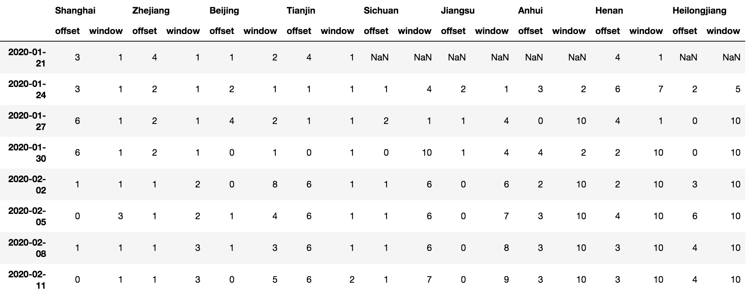

Table 3. “offset” and “window” for 9 regions from January 21th to February 11th

Table 3 can be used as an evaluation of the prevention and control effectiveness of the COVID-19 for each region in each day. The “NaN” values indicate no one has been diagnosed in the regions until those days. The regions are sorted by the values of “offset + window” in February 11th in ascending order, which is the same sorting order of prevention and control effectiveness. We can see the prevention and control effectiveness in Shanghai, which owns the lowest “offset” and “window” values, has done the best job in the 9 regions. On the contrarily, the effectiveness in Heilongjiang is worst.

**Discussion**

**Early Warning Role of This Model in Epidemic Prevention and Control**

From Figure 5, it can be found that the peak of “new” in Heilongjiang happened in February 6th. However, Rome wasn’t built in a day. The peak of “risk” in Heilongjiang is January 24th, when is 13 days before the peak of “new”. And from Table 3, it can be found that the values of “offset” and “window” in Heilongjiang were rising gradually from the first day. Therefore, if the prevention and control of Heilongjiang was done better from the end of January, the number of daily new diagnosed could be lower.

And the warning thresholds could be set roughly from Table 3. When the value of “offset + window” is greater than or equal to 5, there are some problems. When it is greater than or equal to 10, the situation is very serious. The warning values may be related to factors such as the incubation period. If this model is used to evaluate the prevention and control effectiveness for other epidemic, the warning values should be modified accordingly.

**Advantage of This Model over the Method by R0**

The advantage of this model over the evaluation method by R0 [19] is that this model can find the risk of epidemic prevention and control much more early. For example, the first diagnosed person was found in Heilongjiang on January 23th. The “offset” and “window” values of Heilongjiang on that day are 6 and 7. Then, as shown in the Table 3, the overall trend of “offset + window” values were increasing later. However, the method by R0 may only be used at least 5 days after the first diagnosed is found in the region, which is the mean days of incubation period [18].

**More Details of the Formula for Calculating “Risk”**

In Formula 2, the “recent 3 days” in “accumulated_newj” is derived from the following considerations. Through testing, it is found that the fewer days used, the greater the “corr” value is calculated in the later step of the model. It is judged that the number of long-term confirmed diagnosis is difficult to reflect the current “risk” from source regions. But considering the “new” value on a single day fluctuates greatly, and days of suspected patient converted to confirmed patient has a deviation of a few days. Therefore, “recent 3 days” is used here.

On the other hand, it has been also considered the value in the brackets of Formula 1 need to be divided by the total population of the source region before calculate cumulative. It means that when the values of “accumulated_newj” in two source regions are same, the people from the region with smaller total population has greater probability as the virus transmitter moving into the destination region. However, the “corr” values are not improved, but the values of “offset” and “window” are increased to fit the similar “corr”. It is judged that it is easier to be infected with the virus for migrants than non-migrants. So the above Formula 1 was used in the end.

**Related Reports and News Confirm the Correctness of the Model Outputs**

Although the data released which can be used to compare the effectiveness of epidemic prevention and control in different regions is relatively little, data and news of 9 regions mentioned in this paper were found, which can be used for the confirmation for the model.

First, according to the data released by Doctor Lilac Network, the numbers of cumulative diagnosed people are divided into incoming immigrants and inner citizens in only 3 regions: Shanghai, Beijing, and Tianjin. Until February 11th, the data is show as Table 4. We can focus “inner diagnosed rate” and the “offset” and “window” values in Table 3. Shanghai did best control (owns lowest “offset + window” value) and the inner people diagnosed rate is also lowest. Beijing is second, and the rate of Tianjin (also owns highest “offset + window” value) is the highest.

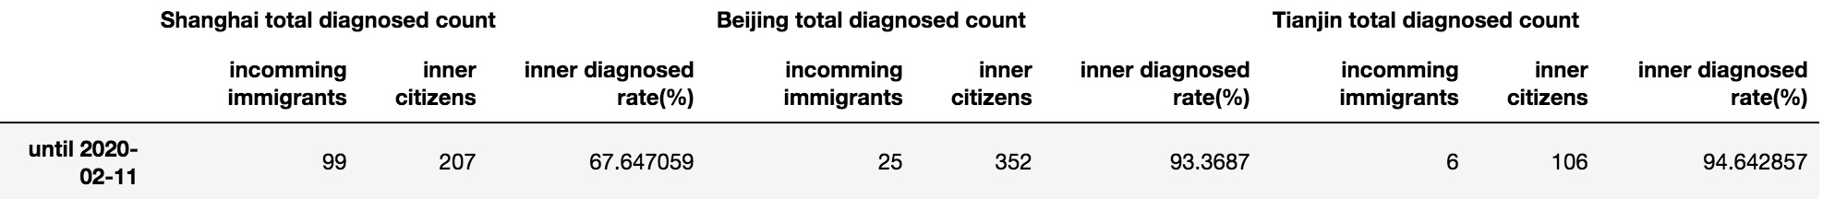

Table 4. The total diagnosed people count divided into incoming immigrants and inner citizens

Second, R0 data of Shanghai, Zhejiang, Jiangsu, Anhui, Henan, and Sichuan were found [19].

The R0 values in the date of the article published (February 10th) are shown as Table 5. Compared with Table 3, we can see the relative values and sorting order of R0 and “offset + window” on the date around February 10th is almost same.

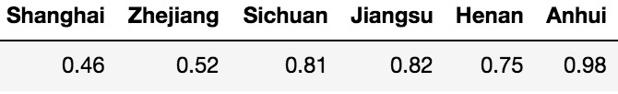

Table 5. The values of R0, “offset” and “window” in February 10th

The correctness of the model output is as confirmed by some related news as follow.

On the one hand, in late January, there were a large number of infected businessmen who were returning to Wenzhou, Zhejiang from Wuhan, Hubei [20]. On February 1th, the government of Wenzhou, Zhejiang issued 25 strict preventions and control measures in a timely manner [21, 22]. On February 22, after the Wenzhou epidemic was completely under control, the Chinese government’s newspaper published an article strongly affirming the achievements of Wenzhou’s epidemic prevention and control [23]. Although Zhejiang (the province where Wenzhou is located) has the huge pressure, Zhejiang did a good job. And the values of “offset” and “window” are relatively low in Table 3.

On the other hand, on February 8th, it is pointed out with survey data that Heilongjiang did not pay enough attention to the epidemic and had poor awareness of prevention [24]. Judging from the “offset” and “window” values of Heilongjiang in Table 3, this is indeed the case.

**Conclusion**

In this study, a model is built by using the number of new daily diagnosed and daily immigration population size data. And the effectiveness of epidemic prevention and control can be evaluated by “offset” and “window”, which are the outputs of the model. The results show that the “offset” and “window” values could change daily with the prevention and control effectiveness. For some regions that were not doing well, warnings had been issued on 2 weeks before the worst days by the “offset” and “window” values. Then the early warning role and advantage of this model over the method by R0 is explained.

Although the “population” data may has different statistical units in other countries, the “population” values used in this model need only be relative values used to calculate the correlation coefficient. Therefore, the model does not use Chinese-specific data. Theoretically, the method of this study is applicable to evaluating the effectiveness of COVID-19 prevention and control in other countries.

**Sincere hopes**

If the epidemic situation is well controlled, the virus is not terrible. Now the daily new diagnosed in most regions of China is quickly reduced to zero or close to zero. Chinese can do a good job in the face of huge epidemic pressure. Therefore, if other countries can do well in prevention and control, the epidemic in those places can also pass quickly.

At present, although the epidemic prevention and control in China has achieved great results, it continues. New outbreaks are gradually emerging around the world. I hope this study can contribute to the prevention and control of the world epidemic. It’s like a Chinese saying, we, the people all over the world, live in a global village, and we are a family. Chinese people hope that the epidemic will be brought under control worldwide as soon as possible and finally ended.

**References**

1. CCTV Network: “Banquet for ten thousand people” turns into “disastrous banquet”, and the history should not be repeated. CCTV Network. URL: <http://news.cctv.com/2020/02/06/ARTI7I0Kl8rF7E1ruR41iR5v200206.shtml> [accessed 2020-02-06]

2. Notice of the general office of the state council on extending the Spring Festival Holiday of 2020. Chinese Government. <http://www.gov.cn/zhengce/content/2020-01/27/content_5472352.htm>

3. Summary of closure information for tourist attractions and some venues across the country. Happy Chaobai River Community in Sohu.com. URL: <https://www.sohu.com/a/368851082_717402> [accessed 2020-01-25]

4. Lanjuan Li, Academician of Chinese academy of engineering: attention should be paid to infectivity of COVID-19 during incubation period. China News. URL: <http://www.chinanews.com/sh/2020/01-22/9067646.shtml> [accessed 2020-01-22]

5. Epidemic situation in real time. Doctor Lilac Network. URL: <https://ncov.dxy.cn/ncovh5/view/pneumonia> [accessed 2020-01-20]

6. Epidemic real-time big data report. Baidu. URL: <https://voice.baidu.com/act/newpneumonia/newpneumonia/> [accessed 2020-01-20]

7. Real-time outbreak tracking. Tencent. URL: <https://news.qq.com/zt2020/page/feiyan.htm#/> [accessed 2020-01-20]

8. Using big data to prevent and control epidemics. Cyberspace Administration of China and Office of the Central Cyberspace Affairs Commission. URL: <http://www.cac.gov.cn/2020-02/17/c_1583484435541835.htm> [accessed 2020-02-17]

9. Ministry of industry and information technology: strengthen big data analysis to support epidemic prevention and control. Economic Daily. URL: <https://baijiahao.baidu.com/s?id=1658594919216396522> [accessed 2020-02-15]

10. Zhejiang takes the lead in achieving full coverage of “Health Code”. Chinese Government. URL: <http://www.gov.cn/xinwen/2020-02/18/content_5480261.htm> [accessed 2020-02-18]

11. Chongqing “Health Code” goes online and people go back to work. Chinese Government. URL: <http://www.gov.cn/xinwen/2020-02/19/content_5481017.htm> [accessed 2020-02-19]

12. Tianjin launches “Health Code” to help prevent epidemic resumption. Chinese Government. URL: <http://www.gov.cn/xinwen/2020-02/29/content_5485080.htm>

<http://www.gov.cn/xinwen/2020-03/01/content_5485215.htm> [accessed 2020-02-29]

13. Guidance for prevention and control work in the commerce and trade industry is published, and by using the “Health Code in Shanghai” as a safety assessment tool for employees and customers. Shanghai Municipal Government. URL: <http://www.shanghai.gov.cn/nw2/nw2314/nw32419/nw48516/nw48539/u21aw1431352.html> [accessed 2020-03-03]

14. Jiangsu launches “Health Code”, and the Yangtze River Delta takes the lead in achieving full coverage. URL: <http://www.gov.cn/xinwen/2020-03/05/content_5487067.htm> [accessed 2020-03-05]

15. Li Ying. Vice President of Baidu: Spring Festival return journey is lengthened under epidemic prevention and control. CCTV News. URL: <http://www.cctime.com/html/2020-1-31/1497804.htm> [accessed 2020-01-31]

16. Guang Shi. Epidemic prevention and control from the perspective of big data. State Council Development Research Center. URL: <https://xw.qq.com/cmsid/20200216A0LJVV00?f=newdc> [accessed 2020-02-16]

17. Huiyun Xu. People coming to Shanghai from severely affected regions need to be isolated at home for 14 days strictly. First Financial Network. URL: <https://www.yicai.com/news/100481608.html?clicktime=1580525715>

18. Qun Li, M.Med., Xuhua Guan, Ph.D., Peng Wu, Ph.D., Xiaoye Wang, M.P.H., Lei Zhou, M.Med., Yeqing Tong, Ph.D., Ruiqi Ren, M.Med., Kathy S.M. Leung, Ph.D., Eric H.Y. Lau, Ph.D., Jessica Y. Wong, Ph.D., Xuesen Xing, Ph.D., Nijuan Xiang, M.Med., et al. Early Transmission Dynamics in Wuhan, China, of Novel Coronavirus–Infected Pneumonia. The New England Journal of Medicine, January 29th, 2020 DOI: 10.1056/NEJMoa2001316. URL: <https://www.nejm.org/doi/full/10.1056/NEJMoa2001316?query=featured_home> [accessed 2020-01-29]

19. Qingzhu Dai. When the Epidemic Ends? The Reliable Answer Is Here!. Alibaba Staff Blockchain Alliance. <https://mp.weixin.qq.com/s/6I1onP3jt3G76IYjy9YWlw> [accessed 2020-02-10]

20. Outside Hubei, the City Has the Most Confirmed Diagnoses, with 227 Cases! Wuhan is Their “Second Hometown” Jiang You, China Fund News URL: <http://sa.sogou.com/sgsearch/sgs_tc_news.php?req=36lX5Aw6IoHk0uKWsTZiH9M3ZaYRYhjRcv0vr9jcX6Q=> [accessed 2020-01-31]

21. Wenzhou Launches Comprehensive Prevention and Control Fight. Wenzhou Government. <http://www.wenzhou.gov.cn/art/2020/1/29/art_1217829_41860286.html> [accessed 2020-01-29]

22． Wenzhou Comprehensively Implements "25" Emergency Measures for Epidemic Prevention and Control. Wenzhou Government. <http://www.wenzhou.gov.cn/art/2020/2/1/art_1217828_41865258.html> [accessed 2020-02-01]

23. Wenzhou, Zhejiang: “Fighting” with Epidemic Highlights Wenzhou's Role. People's Daily. URL: <http://news.cyol.com/content/2020-02/22/content_18390200.htm> [accessed 2020-02-22]

24. Why Heilongjiang Has the Highest Number of Confirmed Diagnoses in Northeast of China. Doctor Lilac Network. URL: <https://mama.dxy.com/outbreak/daily-of-nationwide-new?index=20200208&locationIds=999&share=true&entry=Previous_Review> [accessed 2020-02-08]